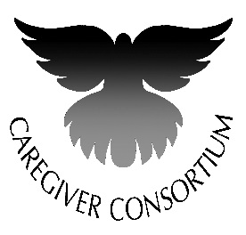
21st Annual Caregiver Conference

A Caregiver’s Harvest: The Journey That Matters

Friday, November 18, 2016

DoubleTree Hotel, 445 S. Alvernon Way

Sponsorship/Exhibitor Levels
$2500 Platinum Sponsor (Must have completed sponsorship form and logo by
Tuesday, September 6, 2016 for logo placement on brochure)
- Includes information in participant packet & recognition from conference emcee
- Logo placement on brochure and prominently displayed at conference
- Full page ad (7.5 w x 10 h inches) in Conference Program
- Display table in prominent area and admission for four* to conference, including meals and materials
$1500 Gold Sponsor (Must have completed sponsorship form and logo by
Tuesday, September 6, 2016 for logo placement on brochure)
This sponsorship will provide Scholarships for family caregivers to attend the conference.
- Logo placement on brochure & prominently displayed at conference
- Full Page ad (7.5 w x 10 h inches) in Conference Program
- Display table in prominent area and Admission for two* to conference, including meals and materials
$1000 Silver Sponsor
- Name placement on brochure & prominently displayed at conference
- Half page ad (7.5 w x 4-7/8” h inches) in Participant Folder & listing on Sponsors Poster at Conference
- Display table in prominent area and Admission for two* to conference, including meals and materials
$550 Copper Sponsor
- One-fourth page ad (3-5/8 w x 4-7/8” h inches) in Participant Handout Folder
- Display table and Admission for two* to conference, including meals and materials
$300 Exhibitor (This level is only available to non-profit 501(c)(3) organizations)
- Display table and admission for one* to conference, including one meal and materials
*Number of registrations includes table representatives.
Registration for representatives includes meals, conference materials and CEUs. Additional conference registrations are available at $40 for family caregivers and
$65 for professional CEUs.

